Module Name: Product & cart
Test case ID:TC_01
Webpage URL:www.demoblaze.com

Scenario ID : 1a

Scenario: View product
Test steps:

1.click on log-in
2.view products

Screenshots:

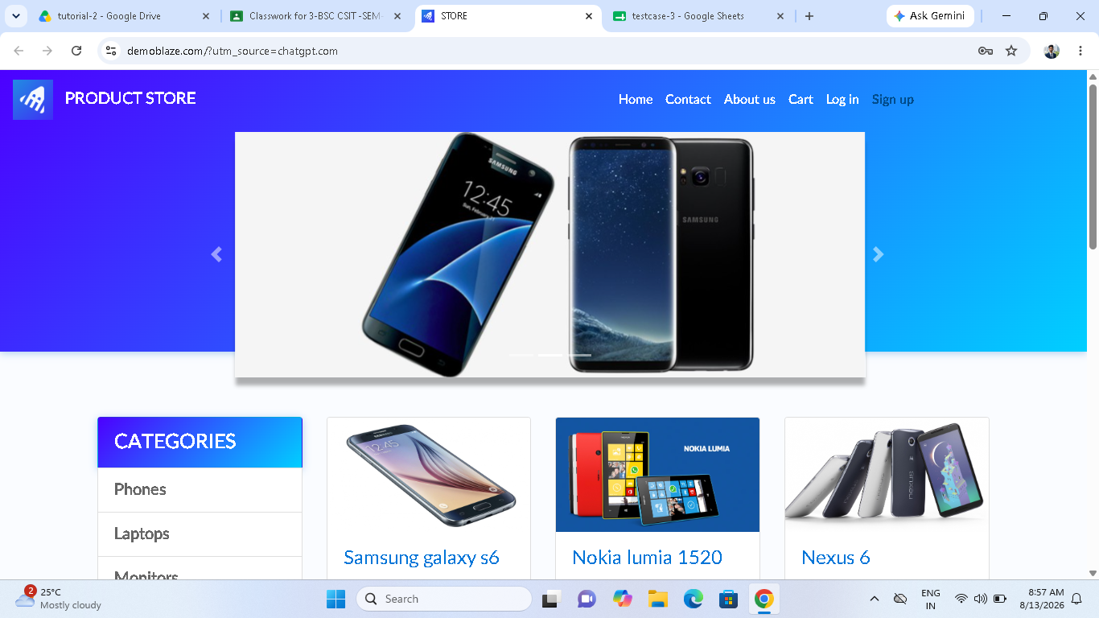

Scenario ID : 1b

Scenario: Select product
Test steps:

1.click on particular product

Screenshots:

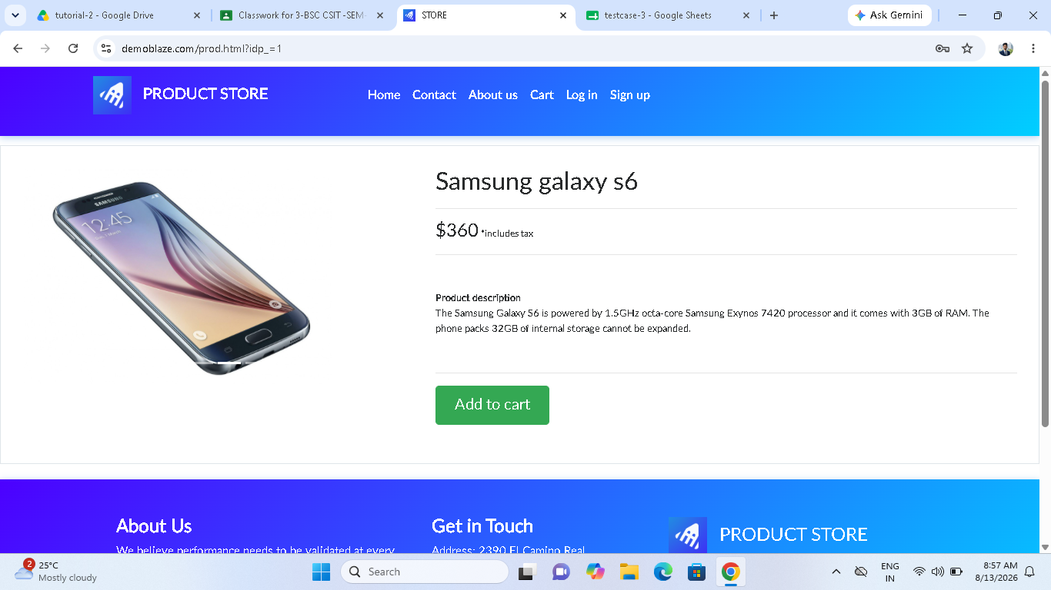

Scenario ID : 1c
Scenario: View product details
Test steps:
1.click on particular product
2.then you can see product details
Screenshots:

Scenario ID : 1d
Scenario: Add product
Test steps:

1.click on product
2.click on add to cart

Screenshots:

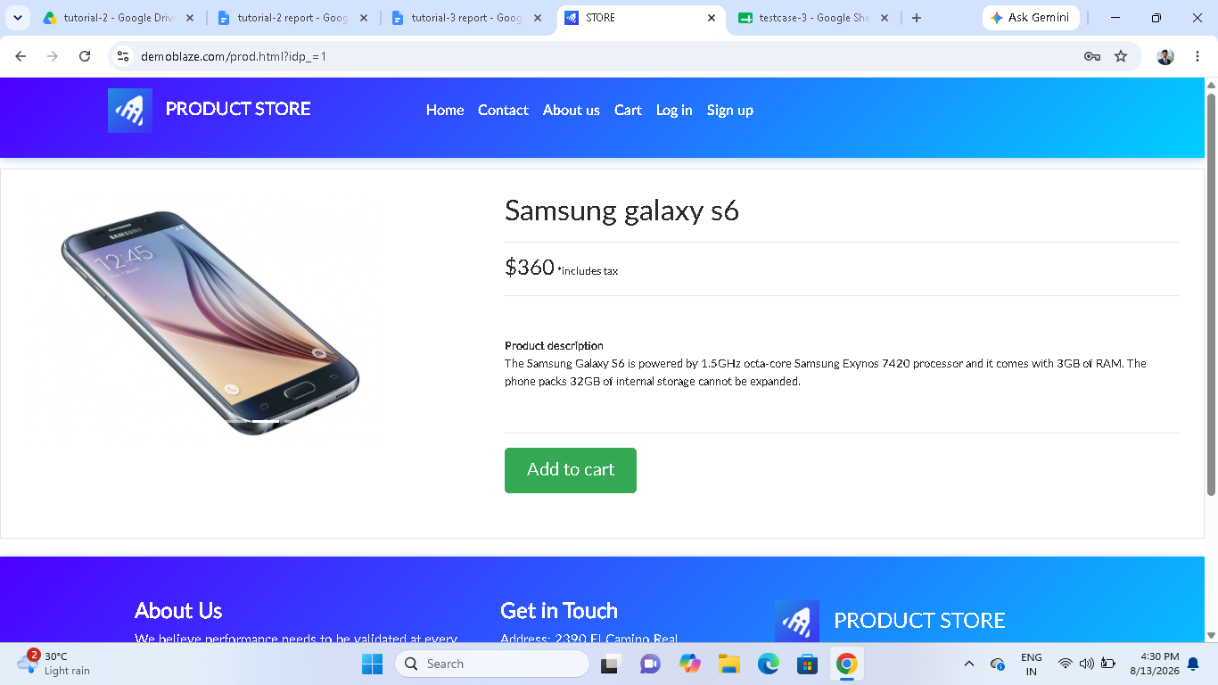

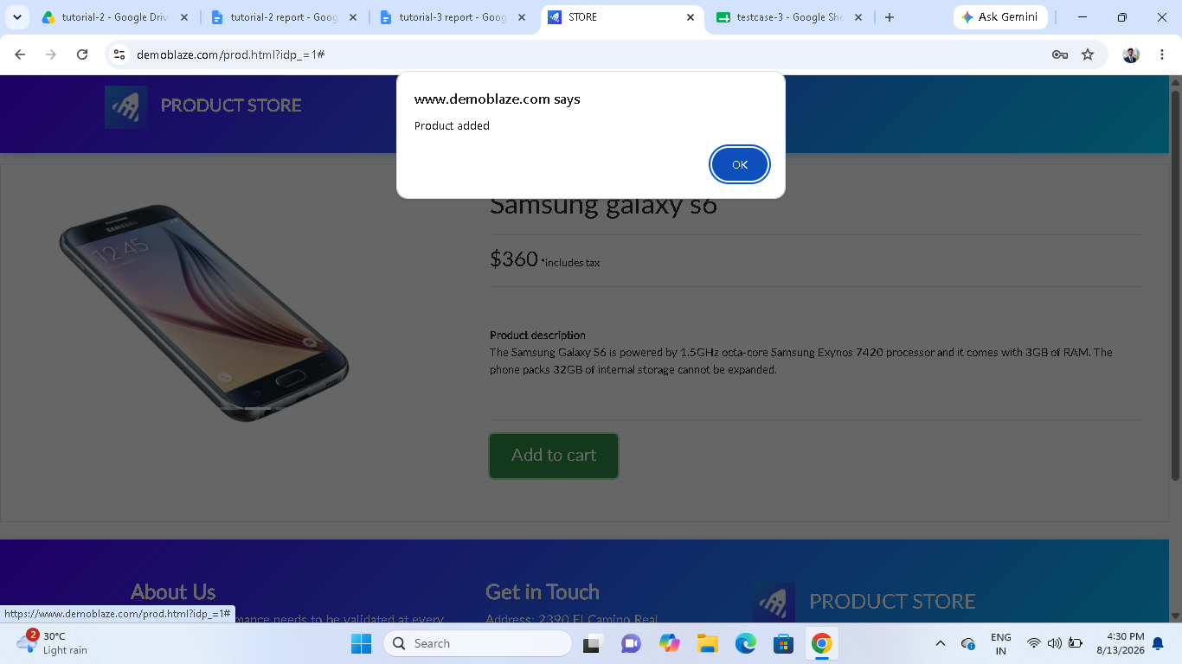

Scenario ID : 1e
Scenario: Open cart
Test steps:

1.click on cart icon in header bar

Screenshots:

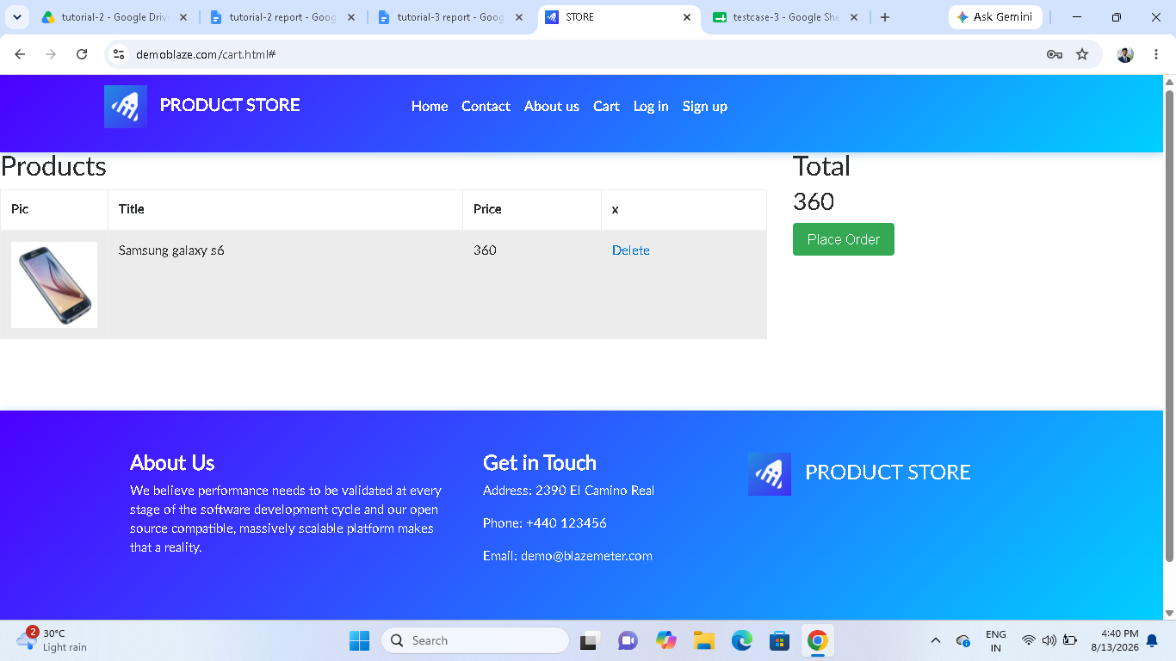

Scenario ID : 2a
Scenario:Verify product in cart
Test steps:
1.Add specific product to the cart
2.click on cart icon

Screenshots:

Scenario ID : 2b
Scenario:remove product
Test steps:
1.Add product to the cart
2.click on cart icon
3.delete the particular product

Screenshots:

